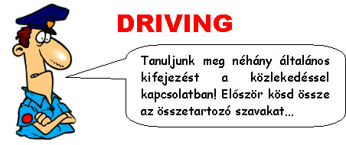
1. traffic  2. petrol  3. unleaded  4. double yellow  5. parking  6. speed  7. reasonable  8. dangerous  9. head-on | a) ticket  b) lines  c) station  d) jam  e) petrol  f) collision  g) driving  h) limit  i) speed
... majd használd mondatban ezeket a kifejezéseket:
- Diesel, ........, and LRP (lead replacement petrol) are the three basic kinds of fuel you can buy at a ........ .
- If you park on ........, you'll get a ........, or you might be towed away.
- Avoid the rush hour and you won't get stuck in a ........ .
- Slown down a bit. There's a 50 mph ........ on this road.
- Two rivers were killed this morning in a ........ on a busy road just outside ........ Derby.
- Paul Smith, who caused the death of a cyclist after ignoring a red light, has been charged with ........ .
- If he'd been driving at a ........, he's have had time to stop.
Végül nézzük a legfontosabb útjelzőtáblák neveit!
 | roundabout | körforgalom
 | crossroads | kereszteződés
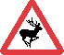 | wild animals | vadállatok
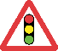 | traffic signals | közlekedési lámpa
 | no stopping | megállni tilos
 | no waiting | várakozni tilos
 | stop and give way | stop és elsőbbségadás
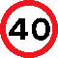 | maximum speed limit | maximum sebességhatár
 | no entry | behajtani tilos
 | one-way street | egyirányú utca
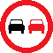 | no overtaking | előzni tilos
 | no right turn | jobbra fordulni tilos
 | give way | elsőbbségadás kötelező
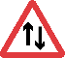 | two way traffic | kétirányú forgalom
Megoldások:
1-a, 2-c, 3-e, 4-b, 5-a, 6-h, 7-i, 8-g, 9-f

